**Nielsen 10 Heuristic Evaluation Template – (Sang hwa Lee, Man of steel)**

Please conduct a heuristic evaluation of the website or mobile application related to your team project by using Nielsen’s 10 Heuristics (e.g., shuttle bus -> <https://peterpanbus.com> )

1. **Describe** one issue that users might experience on the web/app.

First-time visitors may not know how to use the site. It is not configured to be used intuitively by the user.

1. **Take a screenshot** and attach the image below. (add URL link or name of app)

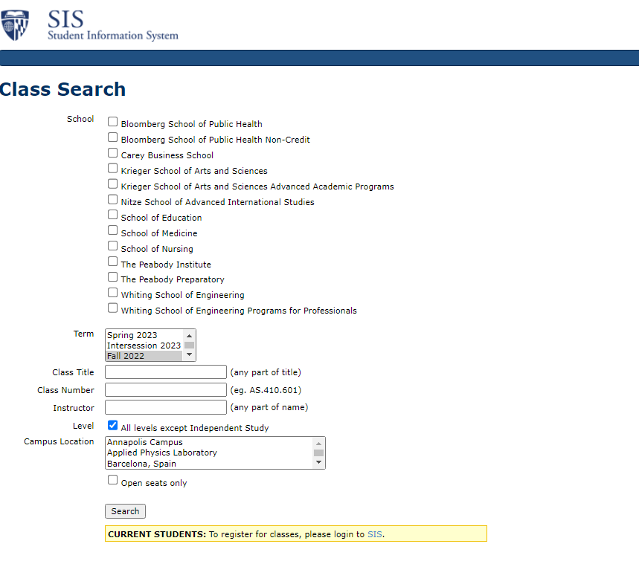

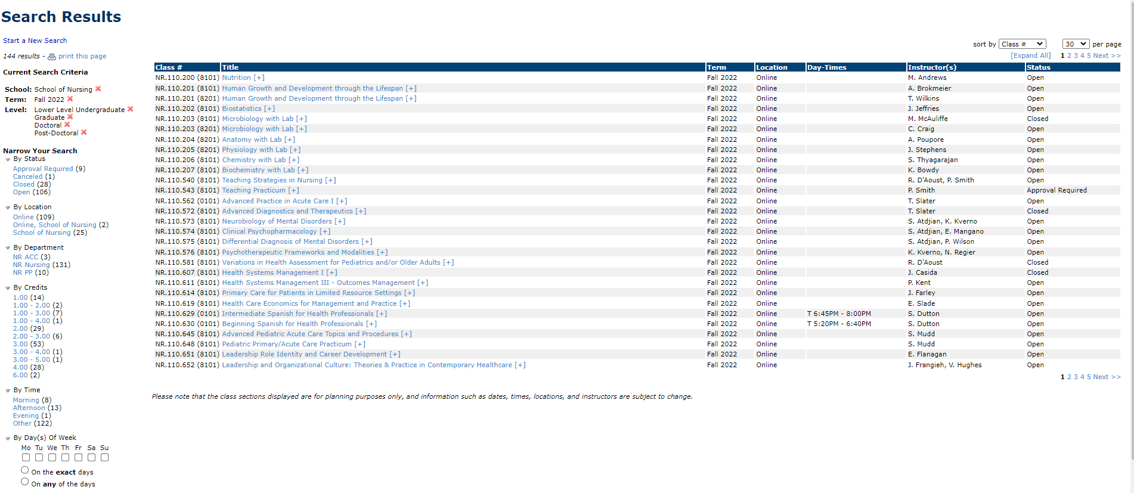

1. **Identify** the violation by using Nielsen’s heuristics (e.g., HE 3 User control and freedom)

It was violated regarding HE8. (HE8 Aesthetic and Minimalist Design)

1. **Assign severity** (1=minor, 2=medium, 3=major)

2 _ It is too complex for users to use. User may be confused about which classes you need.

2 _ Providing too much information that user do not need.

3_ The class, status, and daytime that you use the most are hidden, which can make it difficult for you to find.

1. **How could the issue be fixed?**

If look closely, there are even old materials that users may not need. Modify such information so that users can get only the information they need.

It also configures large sizes of frequently used parts(ex. sort by).

If they have the same class (the class is the same, and only the professor is different), they should create another bar and modify it so that user can check the details below it.